SDG Systems
330 Perry Hwy. STE 200
Harmony, PA 16066

Alice + Olivia
Statement of Work

21-Oct-2025

OVERVIEW
Alice + Olivia (A+O) would like to verify designer clothing that arrives in boxes. The desired application has 2 use cases. First, to receive the boxes that come from manufacturing. Second, to receive and record returns (this implementation is deferred until a later date). The boxes have barcodes on the exterior that include the PO number and box number for incoming manufacturing, and the tracking number for returns. A+O are currently using MC33 handheld units with GS1 Verify. The data is uploaded to GS1 and a spreadsheet is generated. That spreadsheet is fed into their existing BlueCherry ERP system using an in-house macro or script for the spreadsheet.
A+O would like to simplify the solution to use a RFID tunnel and automate the process so that there is less manual interaction. The solution will automatically read the barcodes and RFID tags as they pass through the tunnel, verifying that the correct quantities of each GTIN (EPC) were received. The data will be written to a remote database for BlueCherry.

WORKFLOWS
There is initially just one basic workflow that we are addressing, receiving merchandise. Other workflows are identified, but will not be implemented at this time.

Receiving Merchandise
To receive incoming merchandise, the user at the RFID receiving tunnel will perform the following actions.
- Place the box on the rollers or belt with the barcodes available to be scanned
- Push the box into the tunnel so that the barcodes can be scanned. If the PO number and box number do not appear correctly on the display, reverse the box and ensure the scanner is positioned correctly.
- Push the box through the tunnel and confirm the GTIN (UPC) counts on the display.
If a box is received that does not match the expected quantity, that box will be pulled aside for inspection. Determining the expected quantity is outside of the scope of this software release.
The user will monitor the tunnel display for determining which packages are accepted and which ones need additional inspection.
A sample barcode is shown below:
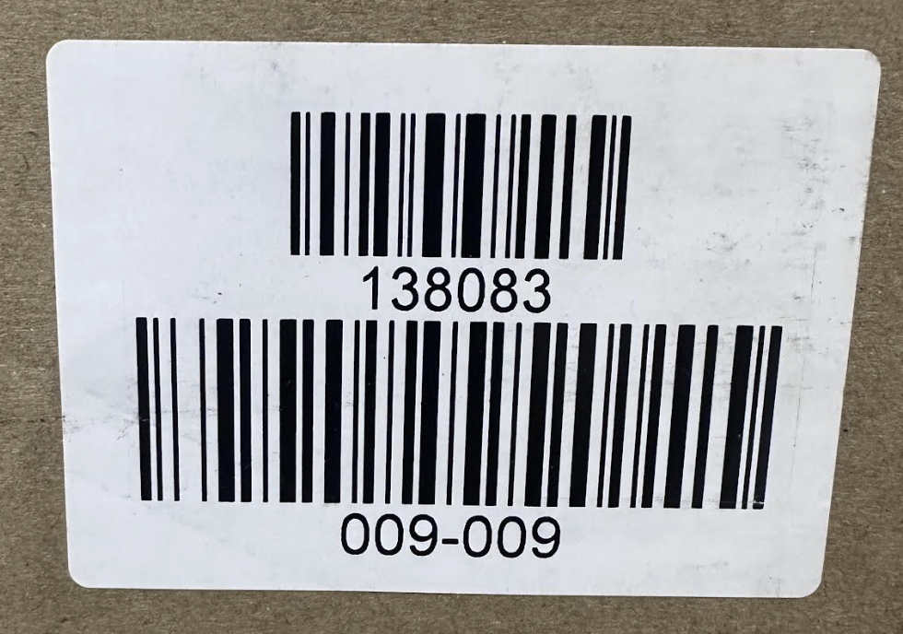

Receiving Returns
Receiving returns is beyond the scope of this implementation phase.

BlueCherry Integration
A+O will configure BlueCherry to have 2 tables for us to use. First, a table with the expected values. It will have the following columns:
- PO number
- Box number
- GTIN
- Qty Expected
The 2nd table will have the same entries except for Qty Received instead of expected.
When the boxes are read, the expected quantity will be compared with the quantity read from RFID, and written when the quantities match. More below.

ASSUMPTIONS
Our understanding of some specific aspects of the project are outlined below:
- The barcodes are easily parsable. That is, when fed into the RFID tunnel, the software will be able to easily determine the PO number, box number and tracking number. The formats for these barcodes will be in the configuration file (e.g. “^\d{6}$” (a 6 digit number) for the PO number and “^\d{3}-\d{3}$” (3 digits, followed by a hyphen, followed by 3 more digits) for the box number). See box label image above.
- The required GS1 validation is only to split the GS1 RFID EPC into its component parts: GTIN (UPC), serialization, etc. The garments will be using SGTIN-96 RFID tags.
- The information that we receive regarding the database tables from which to read and write are accurate. Any discrepancies in the data or database access instructions may result in cost overruns.
- We will not need to undo a recorded RFID read and database write. That is, if we have written to the database table, we will not need to undo or redo that entry.

IMPLEMENTATION
The solution will have 2 primary components required: a custom IoT plugin for the tunnel start / stop and barcode values, and a custom user interface (UI) to display the tunnel data. This application will not use TallyFlow cloud or mobile. The resulting barcode and RFID data reads will be written to the BlueCherry database tables.

RFID and Barcode
The tunnel-included PC will control and receive data from the RFID reader and barcode scanner. RFID EPC values will be parsed and associated with the PO number that is on the barcode. Reading a barcode will trigger the RFID reader to start reading.

Display
We will need to write a custom display application for the data that A+O requires. The application will display the following information:
- PO number or tracking number
- Box number (when applicable)
- GTIN (UPC) numbers in this box
- Counter for each GTIN
- Expected Qty of each GTIN (from BlueCherry)
- Optionally, full EPC list

Database connectivity
A+O will provide 2 database tables for the TallyFlow IoT application to use for monitoring the expected items and for posting the received items. The database is network-local to the TallyFlow IoT tunnel and we will use ODBC or a similar protocol to read and write the database.
Each day at 3am, we will query the database to read the in-transit inventory which will contain the database rows listed above. We will clear out any old entries and use just the new ones read for the comparisons of expected quantities. We will store these in a local on-disk database in case the service is restarted for some reason.
When the received quantity matches the expected quantity, we will automatically write the results to the receiving database table, and inform the user (success screen). If they do not match, we will present an error message on the screen and the user will either try again, override the database update for received quantity, or set the box aside for exception handling. The override functionality implies that we will write a value that is less than or greater than the expected quantity.
If we read PO numbers or Box numbers that do not match those in the table, we will still report the received quantity, but will not update the Received database table. The user will handle this through A+O’s exception policy.

Macro Functionality
Currently, the CSV file that is generated from GS1-Verify is fed into an Excel spreadsheet and compared to a database of registered GS1 GTIN values. This functionality will be moved into the IOT application and automatically generated. The in-house macro takes the UPC number and does a vlookup to match up the Sizes, Color, and Style of what was received.
The custom plugin will read a CSV file that contains the UPC numbers, sizes, etc. to match what was received. The software will produce daily log files of what was received, both in raw format and in a form like the macro file would produce.

ACCEPTANCE CRITERIA
The product and delivery will be considered fully accepted when
- The requirements have been implemented and deployed
- The workflows above can be executed successfully for 30 business days

QUESTIONS
- Where does the spreadsheet “expected_qty” come from? A: It can be ignored
- What is the difference between order number and PO number in the spreadsheet? Is this column overloaded (in its values / purpose)? A: We will use only PO number (not order number)
- Box ID in the spreadsheet seems to have different formats. Please clarify. The sample one has 009-009, for example. Will they always be in that format? A: Yes
- I see both VALIDATE and BOX in the spreadsheet ‘trans_type’ column. Please clarify the use case and current workflow. A: These can be ignored. We will not be doing verification of counts.
- I don’t see the RFID EPC in the spreadsheet. Would you like that added? I think it would be a good idea to have it. A: Yes

CUSTOM WORK ESTIMATE (NRE)

Implementation
SDG will need to add some mobile features to facilitate specifics of the workflow.
TallyFlow UI Custom Application | $6,000
TallyFlow IoT Custom Plugin | $5,000
Customer delivery, acceptance, changes and testing (remote) | $4,000
Total NRE and Delivery | $15,000

Recurring Support
SDG will provide customer and support updates, renewed annually
Total Annual Support and Maintenance (per tunnel) | $1100

